A MINI PROJECT REPORT
ON
SMART CITIES IMPACT ON PREDICTIVE AIR QUALITY MANAGEMENT
Submitted to
SRI INDU COLLEGE OF ENGINEERING & TECHNOLOGY
in partial fulfillment of the requirements for the award of degree of
BACHELOR OF TECHNOLOGY
IN
COMPUTER SCIENCE AND ENGINEERING
Submitted By
A.YUGENDHAR (22D41A0504)
B.ASHRITHA (22D41A0508)
B.KAVYA (22D41A0510)
B.DEEVAN (22D41A0534)
Under the guidance of
Mrs. K.RAJITHA
(Assistant Professor)

DEPARTMENT OF COMPUTER SCIENCE AND ENGINEERING
SRI INDU COLLEGE OF ENGINEERING AND TECHNOLOGY
(An Autonomous Institution under UGC, accredited by NBA, Affiliated to JNTUH) Sheriguda, Ibrahimpatnam.
( 2024 – 2025 )

SRI INDU COLLEGE OF ENGINEERING & TECHNOLOGY
(An Autonomous Institution under UGC, Accredited by NBA, Affiliated to JNTUH) DEPARTMENT OF COMPUTER SCIENCE & ENGINEERING



CERTIFICATE

Certified that the Mini Project entitled “SMART CITIES IMPACT ON PREDICTIVE AIR QUALITY MANAGEMENT” is a Bonafide work carried out by A.YUGENDHAR (22D41A0504), B.ASHRITHA (22D41A0508), B.KAVYA (22D41A0510), B.DEEVAN (22D41A0534) in partial fulfilment for the award of Bachelor of Technology in Computer Science and Engineering of SICET, Hyderabad for the academic year 2024- 2025. The Project has been approved as it satisfies academic requirements in respect of the work prescribed for III YEAR,II SEMESTER of B. TECH course.

INTERNAL GUIDE HEAD OF THE DEPARTMENT
(MrS.K.RAJITHA ) ( Prof.CH.G.V.N.PRASAD)
(Assistant Professor)

EXTERNAL EXAMINER

ACKNOWLEDGMENT
With great pleasure we want to take this opportunity to express our heartfelt gratitude to all the people who helped in making this project work a success. We thank the almighty for giving us the courage & perseverance in completing the project.
We are thankful to principal Prof. Dr. G. Suresh, for giving us the permission to carry out this project and for providing necessary infrastructure and labs.
We are highly indebted to, Prof. CH. GVN. Prasad, Head of the Department of Computer Science & Engineering, Project Guide, for providing valuable guidance at every stage of this project.
We are grateful to our internal project guide, Mrs.K.RAJITHAfor his constant motivation and guidance given by him during the execution of this project work.
We would like to thank the Teaching & Non-Teaching staff of Department of Computer Science & Engineering for sharing their knowledge with us.
Last but not the least we express our sincere thanks to everyone who helped directly or indirectly for the completion of this project.

A.YUGENDHAR (22D41A0504)
B.ASHRITHA (22D41A0508)
B.KAVYA (22D41A0510)
B.DEEVAN (22D41A0534)

ABSTRACT
The Smart City (SC) framework has garnered global recognition for its transformative influence on society through innovative solutions. However, the extensive use of Internet of Things (IoT) devices in SCs raises concerns regarding electronic waste and resource consumption. Addressing this challenge necessitates integrating smart grid systems to safeguard SC residents’ environment and wellbeing. Accurate air quality prediction is essential for informed societal decisions, safe transportation, and disaster preparedness. This study introduces a novel approach: Towards Cleaner Industries: Smart Cities’ Impact on Predictive Air Quality Management (SPAM). The SPAM model utilizes a bidirectional stacking mechanism of long short-term memory neural networks, considering spatiotemporal correlations to forecast future air pollutant concentrations. Surpassing conventional methods, SPAM model enhances accuracy while reducing computational complexity. Experimental findings demonstrate enhanced efficiency and accuracy, underscoring its practicality in industrial contexts. The SPAM model represents a significant advancement in promoting environmental sustainability within the SC framework.

INDEX
TOPICS Page.No

➢ Certificates
➢ Acknowledgement
➢ Abstract
➢ Figures/Tables

CHAPTER-1: INTRODUCTION ……………………………...
CHAPTER-2: LITERATURE SURVEY……………………….
CHAPTER-3: SYSTEM ANALYSIS …………………………..
3.1 Existing System …………………………………………………………
3.1.1 Disadvantages ………………………………………………………….
3.2 Proposed System
3.2.1 Advantages
CHAPTER-4: SYSTEM STUDY
4.1 Feasibility Study
CHAPTER-5: FUNCTIONAL REQUIREMENTS
5.1 Hardware Requirements
5.2 Software Requirements
CHAPTER-6: SYSTEM DESIGN
6.1 System Architecture
6.2 Flowchart: Remote user
6.3 Flowchart: Admin
6.4 UML Diagrams
6.4.1 Use case Diagram
6.4.2 Sequence Diagram
6.4.3 Class Diagram
6.4.4 Dataflow Diagram

CHAPTER-7: IMPLEMENTATION
7.1 Technologies used
7.1.1 About Java
7.2 JavaScript, HTML & JSP
CHAPTER-8: CODING
CHAPTER-9: SCREENSHOTS
CHAPTER-10: SYSTEM TESTING
CHAPTER-11: CONCLUSION
11.1 Conclusion
11.2 Future scope
CHAPTER-12: REFERENCES

LIST OF FIGURES

S.NO | TABLES/FIGURES | PAGE NO’S
1 | System Architecture
2 | UML Diagrams
3 | 6.2.1 Use Case Diagram
4 | 6.2.2 Class Diagram
5 | 6.2.3 Sequence Diagram
6 | 6.2.4 Collaboration Diagram
7 | 6.2.5 Activity Diagram
8 | 6.2.6 Component Diagram
9 | 6.2.7 Deployment Diagram
10 | 6.2.8 ER Diagram
11 | 6.2.9 Data Dictionary
12 | JAVA Source code with compilation
13 | Screenshots

CHAPTER-1
INTRODUCTION
In the development of a smart city (SC), a multifaceted approach is necessary to address urban ecological concerns, encompassing elements such as a weather smart grid (WSG), transportation, healthcare, and intelligent buildings The integration of a WSG holds particular significance in SC development, employing modern technologies to improve weather forecasting accuracy and provide a comprehensive understanding of the environment, thereby assisting in the preparation for extreme weather events, climate variations, and water-related incidents. The impact of a WSG on SCs is significant, underlining the importance of technological advancements in maintaining precise and intelligent weather forecasts.

Urban air pollution is a widespread issue with detrimental effects on human health, contributing to various diseases, including lung cancer. Additionally, air pollution poses severe environmental threats such as acid rain. Consequently, well-calibrated air sensors are currently deployed to monitor air quality, facilitating precise data collection for advanced air prediction, analysis, decision support, clustering, and classification.

Effectively tackling air pollution necessitates proactive prevention and control measures, underscoring the importance of establishing an efficient model for timely evaluation and prediction of air quality. While traditional methods utilize the derived air quality index (AQI) for prediction, recent advancements propose alternative approaches leveraging big data and machine learning (ML). However, these approaches are often constrained by computational costs. Traditional ML methods, focused on classification accuracy, require innovations to reduce computational expenses and enhance time performance.

ML algorithms have been extensively utilized for air quality evaluation, with studies highlighting their suitability for prediction. The integration of artificial intelligence (AI), including traditional ML and deep learning (DL), has yielded successful results in air quality prediction. Various algorithms, such as k-nearest neighbor (KNN), have also found applications. The evolution of ensemble learning has introduced techniques like random forests, leveraging multiple decision trees for predictions. Big data, neural networks (NNs), and DL have been integrated into this domain in recent years. Early examples include the use of artificial neural networks (ANN) and recursive neural networks (RNN) for forecasting air
quality changes. Subsequently, long short-term memory (LSTM) models have been developed to address issues like partial gradient disappearance, showing promise in air quality prediction.

This study addresses concerns regarding computational cost and execution efficiency when dealing with large datasets, aiming to minimize expenses and enhance efficiency while ensuring accuracy. Accordingly, a novel algorithm, an enhanced version of stacked LSTM (SLSTM), is developed for air quality forecasting. Both accuracy and computational complexity are enhanced, leveraging the stacking mechanism to deepen the neural network and improve robustness.

Evaluation metrics such as the receiver operating characteristic (ROC) curve, precision-recall (PR) curve, and confusion matrix (CM) are utilized to assess the improved algorithm’s classification prediction models, illustrating considerable benefits in both precision and computational efficiency, particularly with extensive air quality data.

The decision to employ a Bi-directional Stacked LSTM(BSLSTM) NN for predicting air quality in SCs with WSG integration is driven by the need for precise, adaptable, and efficient models capable of navigating urban complexities. Such models offer valuable insights for pollution management and energy optimization, fostering a healthier and more sustainable urban future. The SPAM model leverages the strengths of BSLSTM networks in handling sequential data, temporal dynamics, and feature extraction, enabling informed predictions. This study makes several noteworthy contributions:
1) This study introducing the bi-directional stacking mechanism of the traditional LSTM neural network to predict future air quality in SCs. Incorporating this mechanism aims to enhance the depth of the model and process time series input data in both directions, thereby improving the accuracy of predictions for future SCs air quality
2) This study formulates 1-hour Prediction Models as the basis for developing the hourly-based SPAM prediction model.
3) The Spatiotemporal Correlation Coefficient metric (ρ)to quantify the internal ρ values among participating air pollutant concentrations (APCs) and meteorological factors (MFs).
4) The SPAM model integrates WSG into the SC framework, enhancing the overall resilience and efficiency of the system.
5) This study presents the industrial application of the proposed SPAM model.

The organization of the study is as follows: Section examines previous research. Section outlines the system architecture and problem formulation of the proposed SPAM model. Section explains the creation of the extensive dataset. Section details the SPAM model, while Section analyzes the experimental findings. Section offers a comprehensive discussion on the scalability of the SPAM model and the management approach for large-scale data from multiple IOT devices in a SC environment. The study concludes in Section and Section describes the future scope of this study.

CHAPTER-2
Literature Survey

1. Title: Air Pollution Forecasting Using Deep Learning LSTM Network
Author:Zhang,Y.,Ding,W.,Chen,Y.
Abstract:
This study explores the use of deep learning, specifically Long Short-Term Memory (LSTM) networks, for air pollution forecasting in urban settings. By training the model on historical pollutant concentrations and meteorological data, the system accurately predicts PM2.5 levels. The LSTM model outperforms traditional machine learning methods, especially in capturing temporal dependencies. The results show improved accuracy and stability, suggesting the LSTM model’s practical applicability in real-time environmental monitoring systems.
2. Title: DeepAir: A Hybrid Deep Learning Model for Urban Air Quality Forecasting
Author:Li,Z.,Liu,Y.,andChen,M.
Abstract:
DeepAir combines convolutional neural networks (CNNs) and LSTMs to handle both spatial and temporal dimensions in air quality prediction. The model processes multi-source data, including traffic, meteorological, and pollutant readings. It significantly reduces prediction error compared to standard models. The authors also implement a data fusion strategy to improve robustness and real-time adaptability. This study highlights the need for integrating diverse inputs in smart city monitoring systems.
3. Title: Spatio-Temporal Air Quality Forecasting Using Bidirectional LSTM Networks
Author:Huang,T.,Zhang,W.,andZhao,J.
Abstract:
This paper proposes a Bi-directional LSTM (BiLSTM) model for capturing the spatiotemporal dynamics of urban air quality. Using data from IoT sensors deployed in multiple locations, the model learns forward and backward time dependencies. It achieves higher forecasting precision, especially in short-term predictions (1–2 hours), and shows strong generalization for large-scale deployments. The authors advocate its use in smart city infrastructure.

CHAPTER-3
SYSTEM ANALYSIS
3.1 EXISTING SYSTEM
Commencing from the latter part of the 1970s, time series analysis methods like regression and auto-encoder decoder models were thoroughly explored in forecasting the concentration levels of various APCs. However, the results were relatively modest, leading to inaccuracies in APCs predictions]. In order to overcome these constraints, Artificial Intelligence (AI) techniques emerge in accurate APCs prediction and in the realm of pollution forecasting, ML algorithms, including Support Vector Machine (SVM), Decision Tree (DT), and Artificial Neural Network (ANN) gained prominence. Nonetheless, these methods struggled to forecast extreme concentrations accurately and faced limitations due to observational constraints. In the mid-2000s, ensemble algorithms were introduced to enhance generalization capability. Techniques like boosting, bagging, and stacking demonstrated high forecasting accuracy in air pollution prediction. Nonetheless, these ensembles carried over constraints from their original algorithms, resulting in failures to predict specific events.
Additionally, the availability of local air quality levels, impacted by human-made emissions associated with transportation, biomass, industrial pollution, and the refining and distribution of fossil fuels, holds a crucial role in forecasting pollution. Hence, leveraging pollution data from local and regional channels facilitates forecasting, empowering the implementation of localized pollution control measures and efficient strategies to mitigate widespread pollution in urban areas. Air pollution monitoring and management heavily relies on the evaluation of air quality. With worsening atmospheric conditions, numerous research articles are dedicated to classifying air quality [28], [29], [30]. Advancements in various methods have significantly improved the accuracy and consistency of related algorithms within the domain of air quality monitoring and management, offering multiple prediction techniques.
The most straightforward and efficient approach involves calculating the AQI based on participating APCs. This method provides direct insights into air
quality, making it well-suited for analyzing air quality status and short-term trends.
Traditional air quality forecasting models are relied on mathematical and statistical techniques involving the design of physical models and encoding data using mathematical equations. However, these calculations can be intricate and may only provide limited accuracy. Recently, alternative approaches utilizing big data and machine learning (ML) methodologies have emerged, leading to improved accuracy in both evaluation and prediction. The integration of conventional ML and deep learning (DL) techniques into air quality assessment has yielded positive outcomes. Decision trees (DTs) have gained popularity in air quality evaluation, with various decision tree algorithms showing impressive outcomes in research on air quality prediction. However, challenges arise with decision trees, particularly as the number of nodes and continuous attributes increase, negatively impacting Commencing performance due to frequent logarithmic operations during information gain calculations. To address these obstacles, ensemble learning techniques like random forests (RFs) have been employed, aggregating multiple decision tree classification models into a resilient ensemble [40].
Neural networks (NNs) and deep learning (DL) techniques have found their way into the field, with the application of ANNs to assess the concentration of various air pollutants and classify air quality grades. Recursive Neural Networks (RNNs) have facilitated the connection and training of multiple layers of neurons with pre-established weights, effectively processing time-series data and predicting future changes in air quality based on past pollutant concentrations.

3.1.1 DISADVANTAGES
- An existing system is not Adaptable to Complex Data Patterns.
- An existing system is not Integration with Weather-Smart Grid (WSG).

3.2 PROPOSED SYSTEM

1) This study introduces the bi-directional stacking mechanism of the traditional system to predict future air quality in SCs. Incorporating this mechanism aims to enhance the depth of the model and process time series input data in both directions, thereby improving the accuracy of predictions for future SCs air quality.
2) This study formulates 1-hour Prediction Models as the basis for developing the hourly-based SPAM prediction model.
3) The Spatiotemporal Correlation Coefficient metric (ρ) to quantify the internal ρ values among participating air pollutant concentrations (APCs) and meteorological factors (MFs).
4) The SPAM model integrates WSG into the SC framework, enhancing the overall resilience and efficiency of the system.
5) This study presents the industrial application of the proposed SPAM model.

3.2.1ADVANTAGES
- To design the proposed architecture of the SPAM model, this proposed system initiate the process by integrating the WSG with the conventional SC framework.
- The proposed SPAM model is designed by following a 3-phase architecture as depicted in the system. Phase 1 is responsible for integrating WSG into the traditional SC framework through access point (AP).

CHAPTER-4
System Study
4.1 FEASIBILITY STUDY
The feasibility of the project is analyzed in this phase and business proposal is put forth with a very general plan for the project and some cost estimates. During system analysis the feasibility study of the proposed system is to be carried out. This is to ensure that the proposed system is not a burden to the company. For feasibility analysis, some understanding of the major requirements for the system is essential. Three key considerations involved in the feasibility analysis are
♦ ECONOMICAL FEASIBILITY
♦ TECHNICAL FEASIBILITY
♦ SOCIAL FEASIBILITY ECONOMICAL FEASIBILITY
This study is carried out to check the economic impact that the system will have on the organization. The amount of funds that the company can pour into the research and development of the system is limited. The expenditures must be justified. Thus the developed system as well within the budget and this was achieved because most of the technologies used are freely available. Only the customized products had to be purchased.
TECHNICAL FEASIBILITY
This study is carried out to check the technical feasibility, that is, the technical requirements of the system. Any system developed must not have a high demand on the available technical resources. This will lead to high demands on the available technical resources. This will lead to high demands being placed on the client. The developed system must have a modest requirement, as only minimal or null changes are required for implementing this system.

SOCIAL FEASIBILITY
The aspect of study is to check the level of acceptance of the system by the user. This includes the process of training the user to use the system efficiently. The user must not feel threatened by the system, instead must accept it as a necessity. The level of acceptance by the users solely depends on the methods that are employed to educate the user about the system and to make him familiar with it. His level of confidence must be raised so that he is also able to make some constructive criticism, which is welcomed, as he is the final user of the system.
CHAPTER-5
SYSTEM REQUIREMENTS
5.1 FUNCTIONAL REQUIREMENTS
- User
- Admin
5.2 HARDWARE REQUIREMENTS
MINIMUM (Required for Execution) |  | MY SYSTEM (Development)
System/Processor | Pentium IV 2.4 GHz | i3 Processor 5th Gen
Hard Disk | 20 Gb | 512 Gb
Ram | 4 Gb | 4 Gb
Key Board | Standard Key Board | Standard Key Board
Mouse | Two or Three Button | Three Button
Monitor | SVGA | SVGA
5.2.2 SOFTWARE REQUIREMENTS
Operating System | Windows XP
Development Software | JAVA 8.1
Programming Language | Java/J2EE (JSP, Servlet)
Front End Technologies | J2EE
Back End | MySQL
CHAPTER-6
System Design

- 6.1 SYSTEM ARCHITECTURE
WEB SERVER

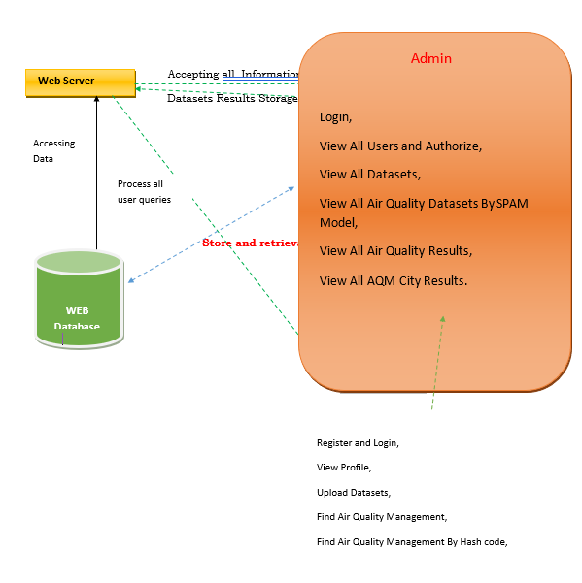
WEB DATABASE


  - UML Diagrams
UML stands for Unified Modeling Language. UML is a standardized general-purpose modeling language in the field of object-oriented software engineering. The standard is managed, and was created by, the Object Management Group.
The goal is for UML to become a common language for creating models of object oriented computer software. In its current form UML is comprised of two major components: a Meta-model and a notation. In the future, some form of method or process may also be added to; or associated with, UML.
The Unified Modeling Language is a standard language for specifying, Visualization, Constructing and documenting the artifacts of software system, as well as for business modeling and other non-software systems.
The UML represents a collection of best engineering practices that have proven successful in the modeling of large and complex systems.

The UML is a very important part of developing objects oriented software and the software development process. The UML uses mostly graphical notations to express the design of software projects.

    - USE CASE DIAGRAM:
A use case diagram in the Unified Modeling Language (UML) is a type of behavioral diagram defined by and created from a Use-case analysis. Its purpose is to present a graphical overview of the functionality provided by a system in terms of actors, their goals (represented as use cases), and any dependencies between those use cases.
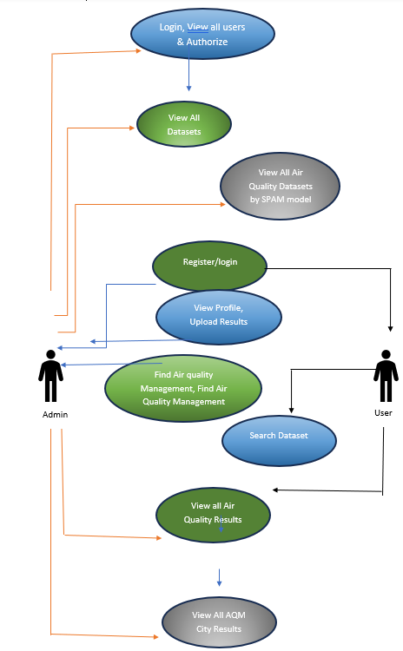

    - CLASS DIAGRAM:
In software engineering, a class diagram in the Unified Modeling Language (UML) is a type of static structure diagram that describes the structure of a system by showing the system's classes, their attributes, operations (or methods), and the relationships among the classes. It explains which class contains information.

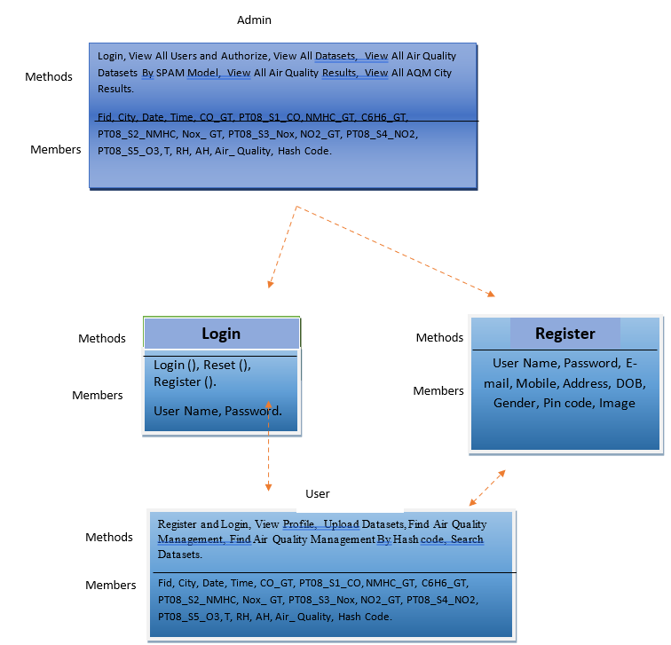

6.2.3 SEQUENCE DIAGRAM
A sequence diagram in Unified Modeling Language (UML) is a kind of interaction diagram that shows how processes operate with one another and in what order. It is a construct of a Message Sequence Chart. Sequence diagrams are sometimes called event diagrams, event scenarios, and timing diagrams.

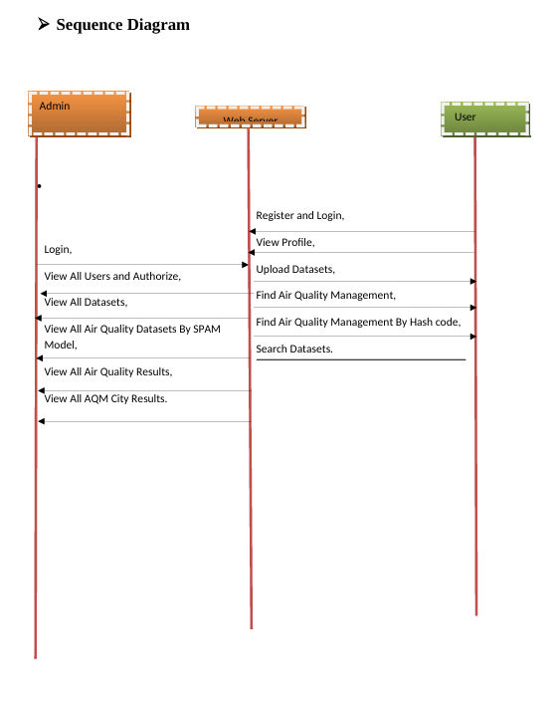
WEB SERVER

logout
logout
6.2.4 COLLABRATION DIAGRAM
A collaboration diagram, also known as a communication diagram, is an illustration of the relationships and interactions among software objects in the Unified Modeling Language (UML). These diagrams can be used to portray the dynamic behavior of a particular use case and define the role of each object.

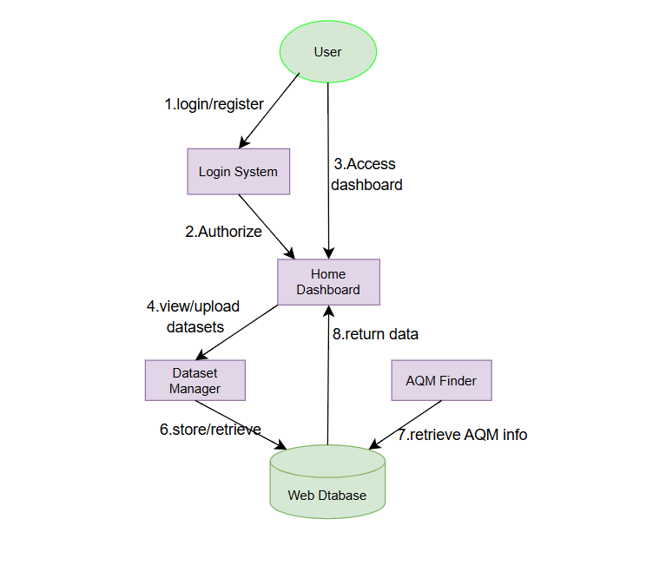

    - ACTIVITY DIAGRAM
Activity diagrams are graphical representations of workflows of stepwise activities and actions with support for choice, iteration and concurrency. In the Unified Modeling Language, activity diagrams can be used to describe the business and operational step-by-step workflows of components in a system. An activity diagram shows the overall flow of control

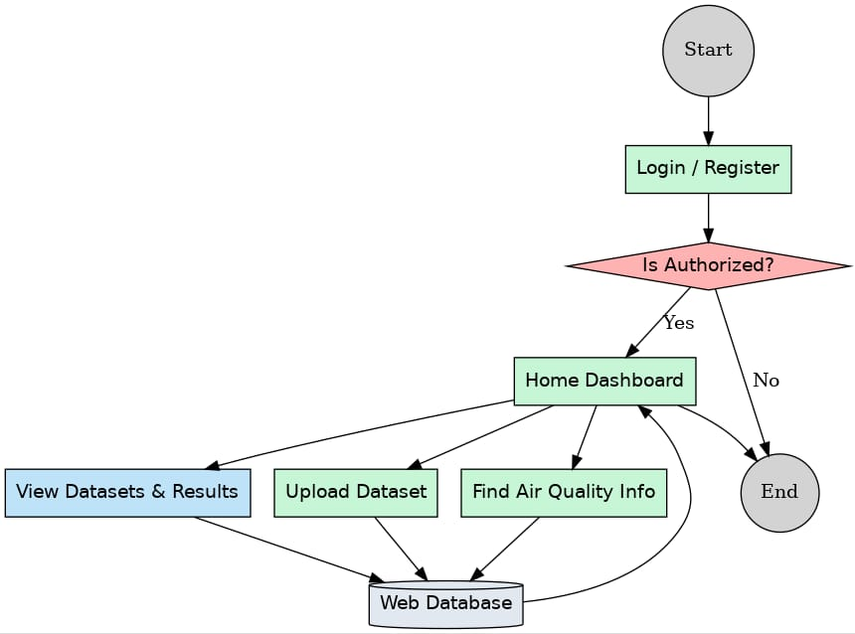

    - COMPONENT DIAGRAM
A component diagram is used to break down a large object-oriented system into the smaller components, so as to make them more manageable. It models the physical view of a system such as executables, files, libraries, etc. that resides within the node It visualizes the relationships as well as the organization between the components present in the system. It helps in forming an executable system.
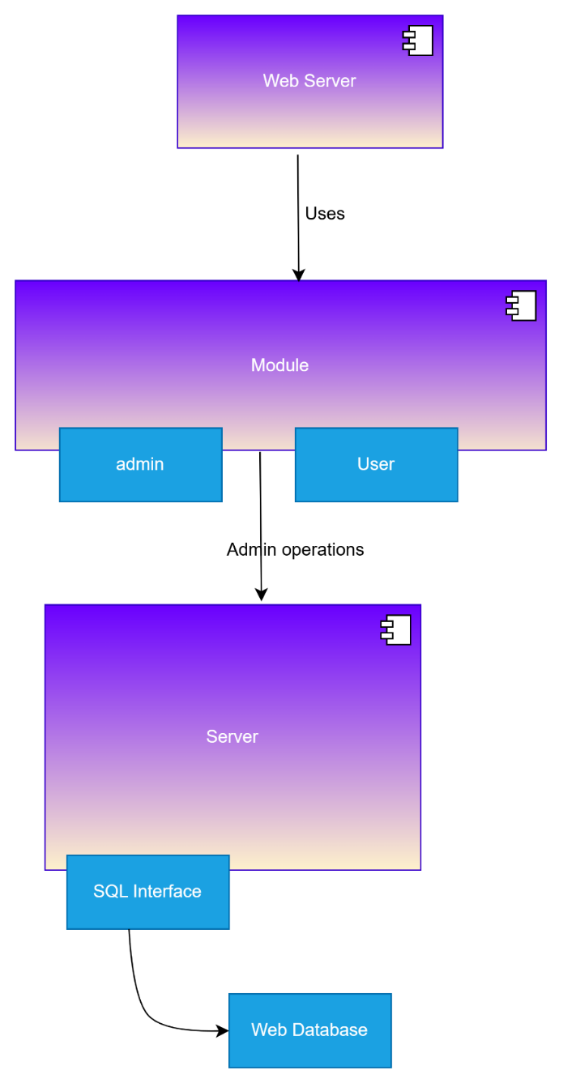

6.2.7DEPLOYMENT DIAGRAM
Deployment diagrams are typically used to visualize the physical hardware and software of a system. Using it you can understand how the system will be physically deployed on the hardware. Deployment diagrams help model the hardware topology of a system compared to other UML diagram types which mostly outline the logical components of a system.

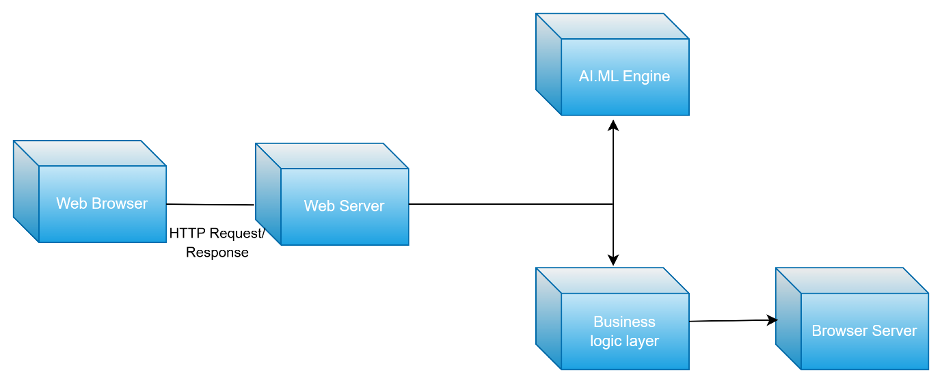

ER Diagram
The Entity Relationship Diagram explains the relationship among the entities present in the database. ER models are used to model real-world objects like a person, a car, or a company and the relation between these real-world objects. In short, the ER Diagram is the structural format of the database.

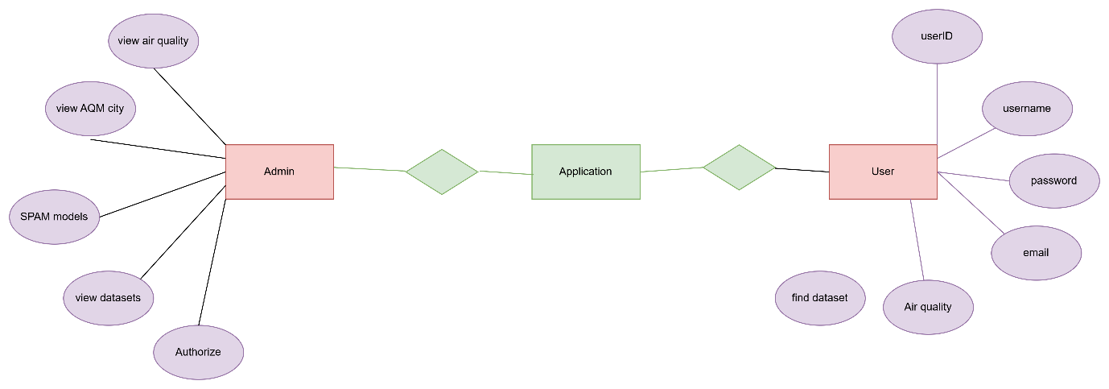

CHAPTER-7
IMPLEMENTATION

Technologies Used:
Oracle
PL/SQL Programming by Scott Urman
SQL complete reference by Livion

JAVA Technologies:
JAVA Complete Reference
Java Script Programming by Yehuda Shiran
Mastering JAVA Security
JAVA2 Networking by Pistoria
JAVA Security by Scotl oaks
Head First EJB Sierra Bates
J2EE Professional by Shadab siddiqui
JAVA server pages by Larne Pekowsley
JAVA Server pages by Nick Todd
HTML
HTML Black Book by Holzner
JDBC
Java Database Programming with JDBC by Patel moss.
Software Engineering by Roger Pressman

About Java
Initially the language was called as “oak” but it was renamed as “Java” in 1995. The primary motivation of this language was the need for a platform-independent (i.e., architecture neutral) language that could be used to create software to be embedded in various consumer electronic devices.
- Java is a programmer’s language.
- Java is cohesive and consistent.
- Except for those constraints imposed by the Internet environment, Java gives the programmer, full control.
Finally, Java is to Internet programming where C was to system programming.

Importance of Java to the Internet
Java has had a profound effect on the Internet. This is because; Java expands the Universe of objects that can move about freely in Cyberspace. In a network, two categories of objects are transmitted between the Server and the Personal computer. They are: Passive information and Dynamic active programs. The Dynamic, Self-executing programs cause serious problems in the areas of Security and probability. But, Java addresses those concerns and by doing so, has opened the door to an exciting new form of program called the Applet.

Java can be used to create two types of programs
Applications and Applets: An application is a program that runs on our Computer under the operating system of that computer. It is more or less like one creating using C or C++. Java’s ability to create Applets makes it important. An Applet is an application designed to be transmitted over the Internet and executed by a Java –compatible web browser. An applet is actually a tiny Java program, dynamically downloaded across the network, just like an image. But the difference is, it is an intelligent program, not just a media file. It can react to the user input and dynamically change.
JAVASCRIPT
JavaScript is a script-based programming language that was developed by Netscape Communication Corporation. JavaScript was originally called Live Script and renamed as JavaScript to indicate its relationship with Java. JavaScript supports the development of both client and server components of Web-based applications. On the client side, it can be used to write programs that are executed by a Web browser within the context of a Web page. On the server side, it can be used to write Web server programs that can process information submitted by a Web browser and then updates the browser’s display accordingly
Even though JavaScript supports both client and server Web programming, we prefer JavaScript at Client side programming since most of the browsers supports it. JavaScript is almost as easy to learn as HTML, and JavaScript statements can be included in HTML documents by enclosing the statements between a pair of scripting tags
<SCRIPTS>..</SCRIPT>.
<SCRIPT LANGUAGE = “JavaScript”>
JavaScript statements
</SCRIPT>
Here are a few things we can do with JavaScript :
- Validate the contents of a form and make calculations.
- Add scrolling or changing messages to the Browser’s status line.
- Animate images or rotate images that change when we move the mouse over them.
- Detect the browser in use and display different content for different browsers.
- Detect installed plug-ins and notify the user if a plug-in is required.
We can do much more with JavaScript, including creating entire application.
- JavaScript can be used for Sever-side and Client-side scripting.
- It is more flexible than VBScript.
- JavaScript is the default scripting languages at Client-side since all the browsers supports it.
Hyper Text Markup Language
Hypertext Markup Language (HTML), the languages of the World Wide Web (WWW), allows users to produces Web pages that include text, graphics and pointer to other Web pages (Hyperlinks).
HTML is not a programming language but it is an application of ISO Standard 8879, SGML (Standard Generalized Markup Language), but specialized to hypertext and adapted to the Web. The idea behind Hypertext is that instead of reading text in rigid linear structure, we can easily jump from one point to another point. We can navigate through the information based on our interest and preference. A markup language is simply a series of elements, each delimited with special characters that define how text or other items enclosed within the elements should be displayed. Hyperlinks are underlined or emphasized works that load to other documents or some portions of the same document.
HTML can be used to display any type of document on the host computer, which can be geographically at a different location. It is a versatile language and can be used on any platform or desktop.
HTML provides tags (special codes) to make the document look attractive. HTML tags are not case-sensitive. Using graphics, fonts, different sizes, color, etc., can enhance the presentation of the document. Anything that is not a tag is part of the document itself.

Basic HTML Tags:
<!--………. --> Specifies comments
<A>………</A> Creates hypertext links
<B>………</B> Formats text as bold
<BIG>……</BIG> Formats text in large font.
<BODY>…</BODY> Contains all tags and text in the HTML document
<CENTER>...</CENTER> Creates text
<DD>…</DD> Definition of a term
<DL>...</DL> Creates definition list
<FONT>…</FONT> Formats text with a particular font
<FORM>...</FORM> Encloses a fill-out form
<FRAME>...</FRAME> Defines a particular frame in a set of frames
<H#>…</H#> Creates headings of different levels
<HEAD>...</HEAD> Contains tags that specify information about a document
<HR>...</HR> Creates a horizontal rule
<HTML>…</HTML> Contains all other HTML tags
<META>...</META> Provides meta-information about a document
<SCRIPT>…</SCRIPT> Contains client-side or server-side script
<TABLE>…</TABLE> Creates a table
<TD>…</TD> Indicates table data in a table
<TR>…</TR> Designates a table row
<TH>…</TH> Creates a heading in a table
ADVANTAGES
- A HTML document is small and hence easy to send over the net. It is small because it does not include formatted information.
- HTML is platform independent.
- HTML tags are not case-sensitive.

JAVA SERVER
Java server Pages is a simple, yet powerful technology for creating and maintaining dynamic-content web pages. Based on the Java programming language, Java Server Pages offers proven portability, open standards, and a mature re-usable component model .The Java Server Pages architecture enables the separation of content generation from content presentation. This separation not eases maintenance headaches, it also allows web team members to focus on their areas of expertise. Now, web page designer can concentrate on layout, and web application designers on programming, with minimal concern about impacting each other’s work.

Steps in the execution of a JSP Application:
- The client sends a request to the web server for a JSP file by giving the name of the JSP file within the form tag of a HTML page.
- This request is transferred to the Java Web Server. At the server side Java Web Server receives the request and if it is a request for a js file server gives this request to the JSP engine.
- JSP engine is program which can understands the tags of the jsp and then it converts those tags into a Servlet program and it is stored at the server side. This Servlet is loaded in the memory and then it is executed and the result is given back to theJava WebServer and then it is transferred back to the result is givenback to the JavaWeb Server and then it is transferred back to the client.

CHAPTER-8
Coding

8.SAMPLE CODE
<!DOCTYPE html PUBLIC "-//W3C//DTD XHTML 1.0 Transitional//EN" "http://www.w3.org/TR/xhtml1/DTD/xhtml1-transitional.dtd">
<html xmlns="http://www.w3.org/1999/xhtml">
<head>
<title>User Login...</title>
<meta http-equiv="Content-Type" content="text/html; charset=utf-8" />
<link href="css/style.css" rel="stylesheet" type="text/css" />
<link rel="stylesheet" type="text/css" href="css/coin-slider.css" />
<script type="text/javascript" src="js/cufon-yui.js"></script>
<script type="text/javascript" src="js/cufon-times.js"></script>
<script type="text/javascript" src="js/jquery-1.4.2.min.js"></script>
<script type="text/javascript" src="js/script.js"></script>
<script type="text/javascript" src="js/coin-slider.min.js"></script>
<style type="text/css">
<!--
.style4 {font-size: 18px}
.style7 {color: #FF00FF}
-->
</style>
<script language="javascript" type="text/javascript">
function valid()
{
var na3=document.s.userid.value;
if(na3=="")

{
alert("Please Enter User Name");
document.s.userid.focus();
return false;
}
else
{

}
var na4=document.s.pass.value;
if(na4=="")

{
alert("Please Enter Password");
document.s.pass.focus();
return false;
}

}
</script>
</head>
<body>
<div class="main">
<div class="header">
<div class="header_resize">
<div class="searchform"></div>
<div class="logo">
<h1><a href="index.html"><span class="style4">Toward Cleaner Industries Smart Cities Impact on Predictive Air Quality Management</span></a></h1>
</div>
<div class="clr"></div>
<div class="menu_nav">
<ul>
<li><a href="index.html"><span>HOME PAGE</span></a></li>
<li><a href="A_Login.jsp">ADMIN</a></li>
<li class="active"><a href="U_Login.jsp"><span>USER</span></a></li>
</ul>
</div>
<div class="clr"></div>
<div class="slider">
<div id="coin-slider"><a href="#"><imgsrc="images/slide1.jpg" width="920" height="360" alt="" /><span><big>Sed </big></span></a><a href="#"><imgsrc="images/slide2.jpg" width="920" height="360" alt="" /><span><big>Amet </big></span></a><a href="#"><imgsrc="images/slide3.jpg" width="920" height="360" alt="" /><span><big>Sed </big></span></a></div>
<div class="clr"></div>
</div>
<div class="clr"></div>
</div>
</div>
<div class="content">
<div class="content_resize">
<div class="mainbar">
<div class="article">
<h2><span class="style7">Wel-come to User Login </span></h2>
<p><imgsrc="images/Login.jpg" width="220" height="146" /></p>
<form name="s" action="Authentication.jsp?value=<%="userlogin"%>" method="post" onSubmit="return valid()" ons target="_top">
<table width="660" align="left">
<tr>
<td width="162" height="35"><span class="style7">User Name (required)</span></td>
<td width="486"><input id="name" name="userid" class="text" /></td>
</tr>
<tr>
<td height="38"><span class="style7">Password (required)</span></td>
<td><input type="password" id="password" name="pass" class="text" /></td>
</tr>

<tr><td></td>
<td>
<input name="imageField" type="submit" class="style3" id="imageField" value="Login" />
<input name="Reset" type="reset" class="style3" value="Reset" />
New user?<a href="U_Register.jsp">Register </a></td>
</tr>

</p>
<p>&nbsp;</p>
</table>
</form>
<div class="clr"></div>
<div class="img"></div>
<div class="clr"></div>
</div>
</div>
<div class="sidebar">
<div class="gadget">
<h2 class="star"><span>Sidebar</span> Menu</h2>
<div class="clr"></div>
<ul class="sb_menu">
<li><a href="index.html">Home</a></li>
<li><a href="A_Login.jsp">Admin</a></li>
<li><a href="U_Login.jsp">User</a></li>
</ul>
</div>
</div>
<div class="clr"></div>
</div>
</div>
<div class="fbg"></div>
<div class="footer">
<div class="footer_resize">

<div style="clear:both;"></div>
</div>
</div>
</div>
<div align=center></a></div></body>
</html>

CHAPTER-9
Screenshots
HOMEPAGE
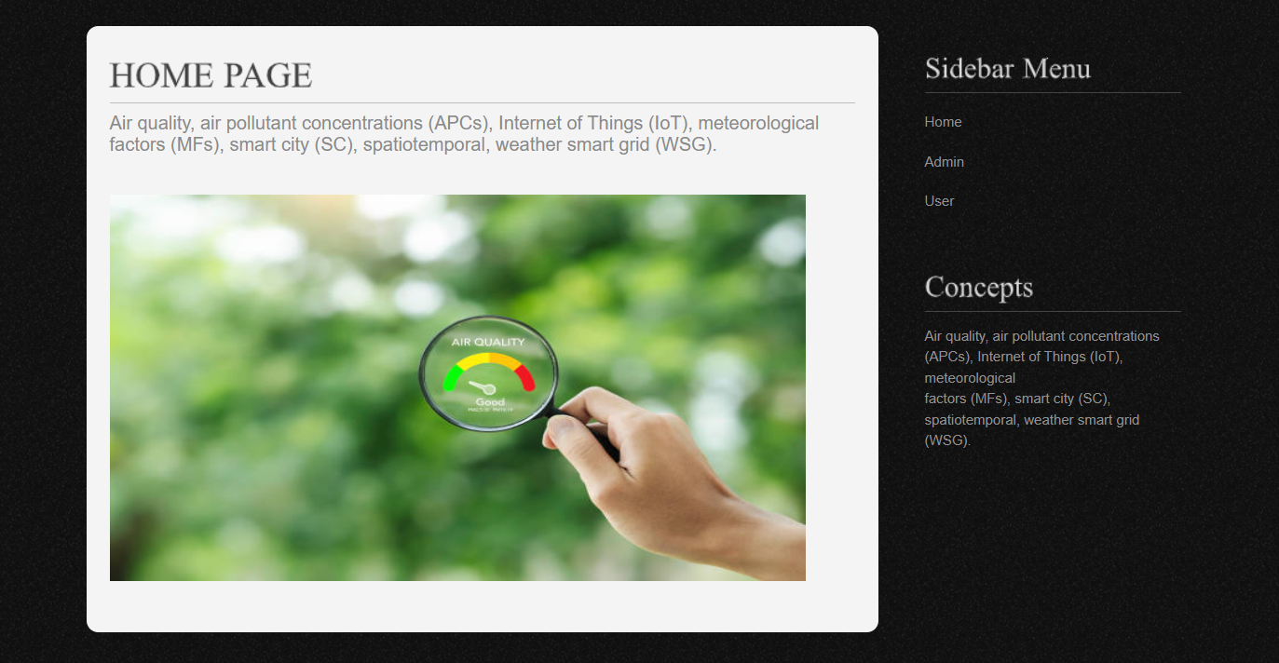
ADMIN LOGIN
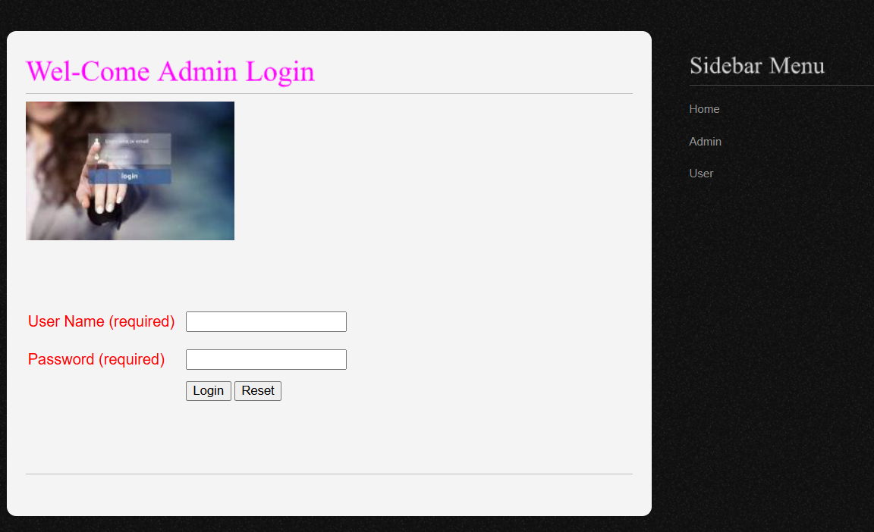

ADMIN HOMEPAGE
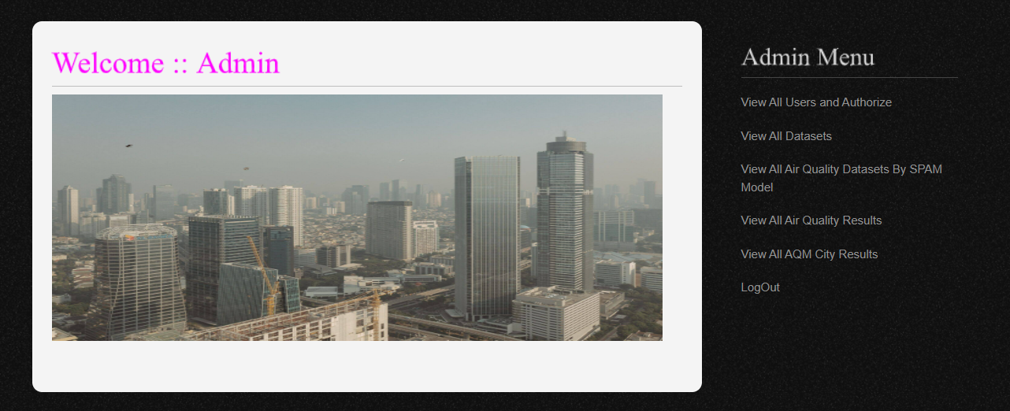
ADMIN OPERATION PAGE
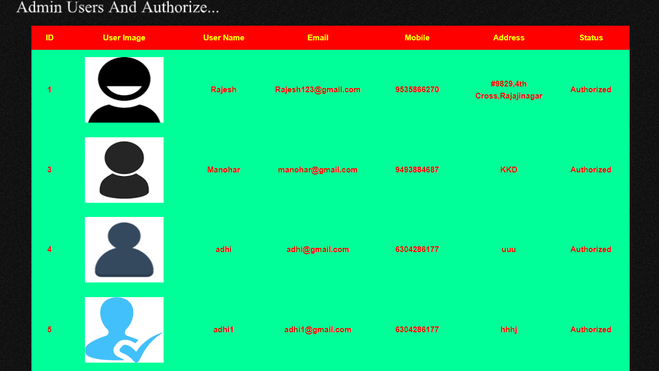

USER LOGIN
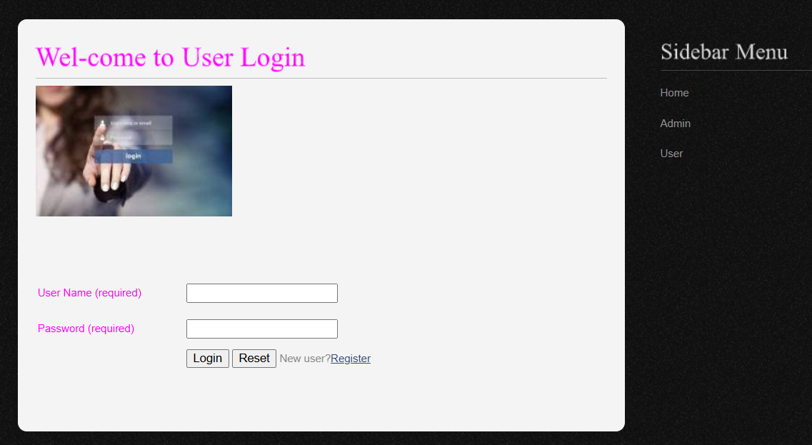

USER REGISTRATION
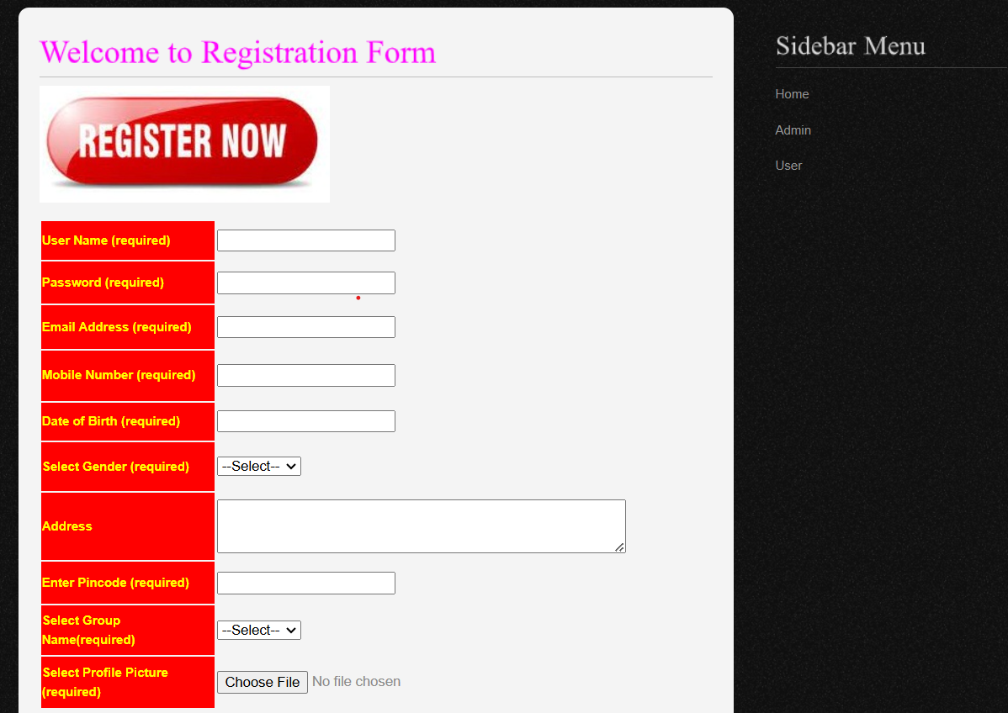

CHAPTER-10

SYSTEM TESTING
The purpose of testing is to discover errors. Testing is the process of trying to discover every conceivable fault or weakness in a work product. It provides a way to check the functionality of components, sub assemblies, assemblies and/or a finished product It is the process of exercising software with the intent of ensuring that the
Software system meets its requirements and user expectations and does not fail in an unacceptable manner. There are various types of test. Each test type addresses a specific testing requirement.

TYPES OF TESTS

Unit testing
Unit testing involves the design of test cases that validate that the internal program logic is functioning properly, and that program inputs produce valid outputs. All decision branches and internal code flow should be validated. It is the testing of individual software units of the application .it is done after the completion of an individual unit before integration. This is a structural testing, that relies on knowledge of its construction and is invasive. Unit tests perform basic tests at component level and test a specific business process, application, and/or system configuration. Unit tests ensure that each unique path of a business process performs accurately to the documented specifications and contains clearly defined inputs and expected results.
Integration testing
Integration tests are designed to test integrated software components to determine if they actually run as one program. Testing is event driven and is more concerned with the basic outcome of screens or fields. Integration tests demonstrate that although the components were individually satisfaction, as shown by successfully unit testing, the combination of components is correct and consistent. Integration testing is specifically aimed a texposing the problems that arise from the combination of components.

Functional test
Functional tests provide systematic demonstrations that functions tested are available as specified by the business and technical requirements, system documentation, and user manuals.
Functional testing is centered on the following items:
Valid Input : identified classes of valid input must be accepted.
Invalid Input : identified classes of invalid input must be rejected.
Functions : identified functions must be exercised.
Output : identified classes of application outputs must be exercised.
Systems/Procedures: interfacing systems or procedures must be invoked.
Organization and preparation of functional tests is focused on requirements, key functions, or special test cases. In addition, systematic coverage pertaining to identify Business process flows; data fields, predefined processes, and successive processes must be considered for testing. Before functional testing is complete, additional tests are identified and the effective value of current tests is determined.

System Test
System testing ensures that the entire integrated software system meets requirements. It tests a configuration to ensure known and predictable results. An example of system testing is the configuration oriented system integration test. System testing is based on process descriptions and flows, emphasizing pre-driven process links and integration points.

White Box Testing
White Box Testing is a testing in which in which the software tester has knowledge of the inner workings, structure and language of the software, or at least its purpose. It is purpose. It is used to test areas that cannot be reached from a black box level.

Black Box Testing
Black Box Testing is testing the software without any knowledge of the inner workings, structure or language of the module being tested. Black box tests, as most other kinds of tests, must be written from a definitive source document, such as specification or requirements document, such as specification or requirements document. It is a testing in which the software under test is treated, as a black box .you cannot “see” into it. The test provides inputs and responds to outputs without considering how the software works.

10.1 Unit Testing:
Unit testing is usually conducted as part of a combined code and unit test phase of the software lifecycle, although it is not uncommon for coding and unit testing to be conducted as two distinct phases.

Test strategy and approach
Field testing will be performed manually and functional tests will be written in detail.
Test objectives
- All field entries must work properly.
- Pages must be activated from the identified link.
- The entry screen, messages and responses must not be delayed.
Features to be tested
- Verify that the entries are of the correct format
- No duplicate entries should be allowed
- All links should take the user to the correct page.

10.2 Integration Testing
Software integration testing is the incremental integration testing of two or more integrated software components on a single platform to produce failures caused by interface defects.
The task of the integration test is to check that components or software applications, e.g. components in a software system or – one step up – software applications at the company level – interact without error.
Test Results: All the test cases mentioned above passed successfully. No defects encountered.

6.3 Acceptance Testing
User Acceptance Testing is a critical phase of any project and requires significant participation by the end user. It also ensures that the system meets the functional requirements.
Test Results: All the test cases mentioned above passed successfully. No defects encountered.

SYSTEM TESTING

TESTING METHODOLOGIES
The following are the Testing Methodologies:
- Unit Testing.
- Integration Testing.
- User Acceptance Testing.
- Output Testing.
- Validation Testing.

Unit Testing
Unit testing focuses verification effort on the smallest unit of Software design that is the module. Unit testing exercises specific paths in a module’s control structure to ensure complete coverage and maximum error detection. This test focuses on each module individually, ensuring that it functions properly as a unit. Hence, the naming is Unit Testing.
During this testing, each module is tested individually and the module interfaces are verified for the consistency with design specification. All important processing path are tested for the expected results. All error handling paths are also tested.
Integration Testing
Integration testing addresses the issues associated with the dual problems of verification and program construction. After the software has been integrated a set of high order tests are conducted. The main objective in this testing process is to take unit tested modules and builds a program structure that has been dictated by design.

The following are the types of Integration Testing:

1)Top Down Integration
This method is an incremental approach to the construction of program structure. Modules are integrated by moving downward through the control hierarchy, beginning with the main program module. The module subordinates to the main program module are incorporated into the structure in either a depth first or breadth first manner.
In this method, the software is tested from main module and individual stubs are replaced when the test proceeds downwards.
2. Bottom-up Integration
This method begins the construction and testing with the modules at the lowest level in the program structure. Since the modules are integrated from the bottom up, processing required for modules subordinate to a given level is always available and the need for stubs is eliminated. The bottom up integration strategy may be implemented with the following steps:
- The low-level modules are combined into clusters into clusters that perform a specific Software sub-function.
- The cluster is tested.
- Drivers are removed and clusters are combined.
- moving upward in theprogram structure

The bottom up approaches tests each module individually and then each module is module is integrated with a main module and tested for functionality.
OTHER TESTING METHODOLOGIES
User Acceptance Testing
User Acceptance of a system is the key factor for the success of any system. The system under consideration is tested for user acceptance by constantly keeping in touch with the prospective system users at the time of developing and making changes wherever required. The system developed provides a friendly user interface that can easily be understood even by a person who is new to the system.
Output Testing
After performing the validation testing, the next step is output testing of the proposed system, since no system could be useful if it does not produce the required output in the specified format. Asking the users about the format required by them tests the outputs generated or displayed by the system under consideration. Hence the output format is considered in 2 ways – one is on screen and another in printed format.
Validation Checking
Validation checks are performed on the following fields.

Text Field:
The text field can contain only the number of characters lesser than or equal to its size. The text fields are alphanumeric in some tables and alphabetic in other tables. Incorrect entry always flashes and error message.

Numeric Field
The numeric field can contain only numbers from 0 to 9. An entry of any character flashes an error messages. The individual modules are checked for accuracy and what it has to perform. Each module is subjected to test run along with sample data. The individually tested modules are integrated into a single system. Testing involves executing the real data information is used in the program the existence of any program defect is inferred from the output. The testing should be planned so that all the requirements are individually tested.
A successful test is one that gives out the defects for the inappropriate data and produces and output revealing the errors in the system.
Preparation of Test Data
Taking various kinds of test data does the above testing. Preparation of test data plays a vital role in the system testing. After preparing the test data the system under study is tested using that test data. While testing the system by using test data errors are again uncovered and corrected by using above testing steps and corrections are also noted for future use.

Using Live Test Data
Live test data are those that are actually extracted from organization files. After a system is partially constructed, programmers or analysts often ask users to key in a set of data from their normal activities. Then, the systems person uses this data as a way to partially test the system. In other instances, programmers or analysts extract a set of live data from the files and have them entered themselves.
It is difficult to obtain live data in sufficient amounts to conduct extensive testing. And, although it is realistic data that will show how the system will perform for the typical processing requirement, assuming that the live data entered are in fact typical, such data generally will not test all combinations or formats that can enter the system. This bias toward typical values then does not provide a true systems test and in fact ignores the cases most likely to cause system failure.

Using Artificial Test Data:
Artificial test data are created solely for test purposes, since they can be generated to test all combinations of formats and values. In other words, the artificial data, which can quickly be prepared by a data generating utility program in the information systems department, make possible the testing of all login and control paths through the program.
The most effective test programs use artificial test data generated by persons other than those who wrote the programs. Often, an independent team of testers formulates a testing plan, using the systems specifications.
The package “Virtual Private Network” has satisfied all the requirements specified as per software requirement specification and was accepted.
USER TRAINING
Whenever a new system is developed, user training is required to educate them about the working of the system so that it can be put to efficient use by those for whom the system has been primarily designed. For this purpose the normal working of the project was demonstrated to the prospective users. Its working is easily understandable and since the expected users are people who have good knowledge of computers, the use of this system is very easy.
MAINTAINENCE
This covers a wide range of activities including correcting code and design errors. To reduce the need for maintenance in the long run, we have more accurately defined the user’s requirements during the process of system development. Depending on the requirements, this system has been developed to satisfy the needs to the largest possible extent. With development in technology, it may be possible to add many more features based on the requirements in future. The coding and designing is simple and easy to understand which will make maintenance easier.

TESTING STRATEGY
A strategy for system testing integrates system test cases and design techniques into a well planned series of steps that results in the successful construction of software. The testing strategy must co-operate test planning, test case design, test execution, and the resultant data collection and evaluation .A strategy for software testing must accommodate low-level tests that are necessary to verify that a small source code segment has been correctly implemented as well as high level tests that validate major system functions against user requirements.
Software testing is a critical element of software quality assurance and represents the ultimate review of specification design and coding. Testing represents an interesting anomaly for the software. Thus, a series of testing are performed for the proposed system before the system is ready for user acceptance testing.

SYSTEM TESTING
Software once validated must be combined with other system elements (e.g. Hardware, people, database). System testing verifies that all the elements are proper and that overall system function performance is achieved. It also tests to find discrepancies between the system and its original objective, current specifications and system documentation.

UNIT TESTING
In unit testing different are modules are tested against the specifications produced during the design for the modules. Unit testing is essential for verification of the code produced during the coding phase, and hence the goals to test the internal logic of the modules. Using the detailed design description as a guide, important Conrail paths are tested to uncover errors within the boundary of the modules. This testing is carried out during the programming stage itself. In this type of testing step, each module was found to be working satisfactorily as regards to the expected output from the module.
In Due Course, latest technology advancements will be taken into consideration. As part of technical build-up many components of the networking system will be generic in nature so that future projects can either use or interact with this.The future holds a lot to offer to the development and refinement of this project.

CHAPTER-11
CONCLUSION
11.1 CONCLUSION
This study has addressed the critical challenge of air quality prediction in SCs by introducing a novel stacked LSTM based recurrent heuristic strategy named the SPAM model. The key findings from our investigation can be summarized as follows:
The SPAM model has demonstrated exceptional effectiveness in predicting air quality, as evidenced by its impressive TPR, FPR, and TNR metrics.
Comparative experiments have highlighted the superiority of the SPAM model over existing methods, surpassing SVM, MLP, RAQP, Vlachogianni, LSTM, BLSTM, and SLSTM models by 36%,26%, 21%, 46%, 20%, 15%, and 10%, respectively.
The SPAM model also demonstrates its industrial applications.

Thus, this study represents a significant advancement in addressing air quality prediction in SCs, showcasing its potential and the industrial applications of the SPAM model. However, further research and refinement are warranted, particularly in understanding non-linear relationships and validating the model with real-world IOT data for practical deployment in SC environments.

11.2 FUTURE SCOPE
The SPAM model has shown strong potential in accurately predicting air quality, but there's still room to grow. Future work could explore how the model handles complex, non-linear environmental factors in real-time. Integrating live IoT sensor data from smart cities would make predictions more relevant and actionable. Testing the model across different regions and seasons could further strengthen its reliability. To make the model more adaptive, researchers can look into self-learning or online learning techniques. Improving interpretability will also help local governments and industries understand predictions better. A mobile or web dashboard could help in real-world decision-making. Collaboration with environmental agencies may lead to stronger validation and deployment opportunities.

CHAPTER-12
References
- P. Kumar, B. Aggarwal, R. Verma, and G. Singh, “Towards sustainable smart cities: Current trends and development,” in Technology and Talent Strategies for Sustainable Smart Cities, S. Dadwal, H. Jahankhani, G. Bowen, and I. Y. Nawaz, Eds., Emerald Publishing Limited, 2023, pp. 117–134, doi: 10.1108/978-1-83753-022-920231006.
- F. Ahsan, N. H. Dana, S. K. Sarker, L. Li, S. Muyeen, M. F. Ali, Z. Tasneem, M. M. Hasan, S. H. Abhi, and M. R. Islam, “Data-driven next generation smart grid towards sustainable energy evolution: Techniques and technology review,” Protection and Control of Modern Power Systems, vol. 8, no. 3, pp. 1–42, 2023.
- S. Conti, C. Fornari, P. Ferrara, I. C. Antonazzo, F. Madotto, E. Traini, M. Levi, A. Cernigliaro, B. Armocida, and N. L. Bragazzi, “Time-trends in air pollution impact on health in Italy, 1990–2019: An analysis from the global burden of disease study 2019,” International Journal of Public Health, vol. 68, Apr. 1990, Art. no. 1605959.
- G. Curci, D. Depalo, and A. Palma, “The dirtier you breathe, the less safe you are: The effect of air pollution on work accidents,” CEIS Working Paper, no. 554, May 2023, doi: 10.2139/ssrn.4370149.
- D. PhamToan, N. VoThiHang, and B. PhamThi, “Improving forecasting model for fuzzy time series using the self-updating clustering and bidirectional long short term memory algorithm,” Expert Systems with Applications, vol. 241, Sep. 2024, Art. no. 122767.
- A. Muneer and S. M. Fati, “Efficient and automated herbs classification approach based on shape and texture features using deep learning,” IEEE Access, vol. 8, pp. 196747–196764, 2020.
- F. Wang, M. Li, Y. Mei, and W. Li, “Time series data mining: A case study with big data analytics approach,” IEEE Access, vol. 8, pp. 14322–14328, 2020.

